**Credential Retrieval Flow**

1. 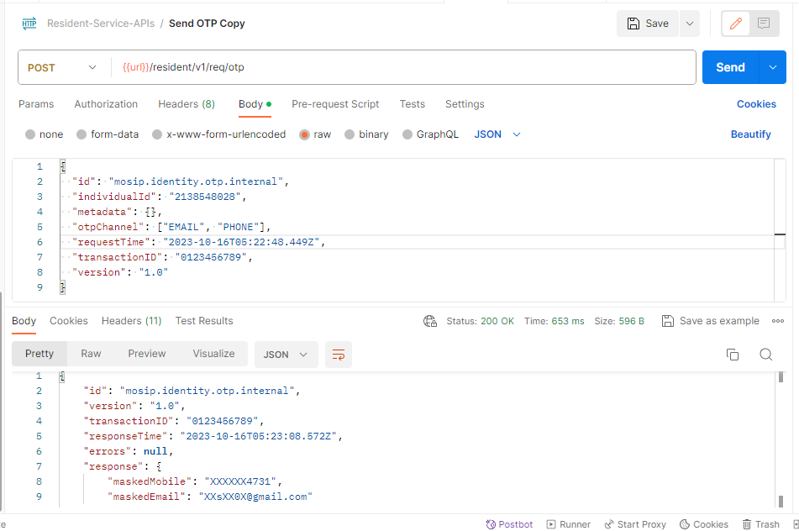Provide individual ID for which credential has to be retrieved.

Notification

1. 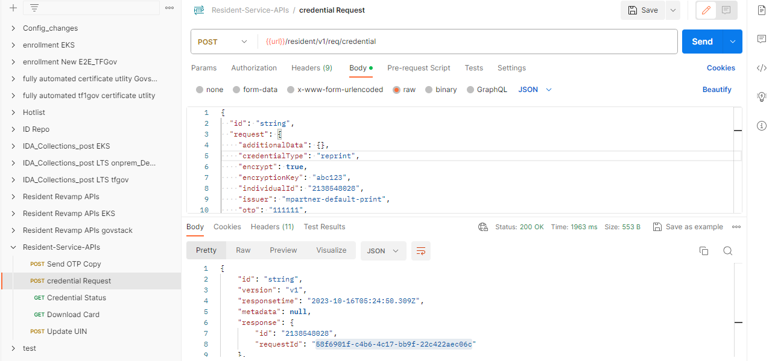Retrieve the exact credential information instead of regenerating the credential when it is lost or stolen.

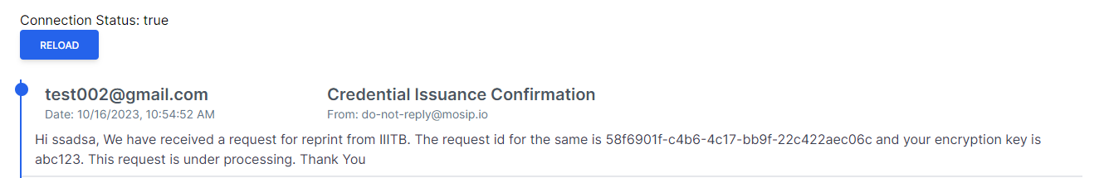Notification

1. 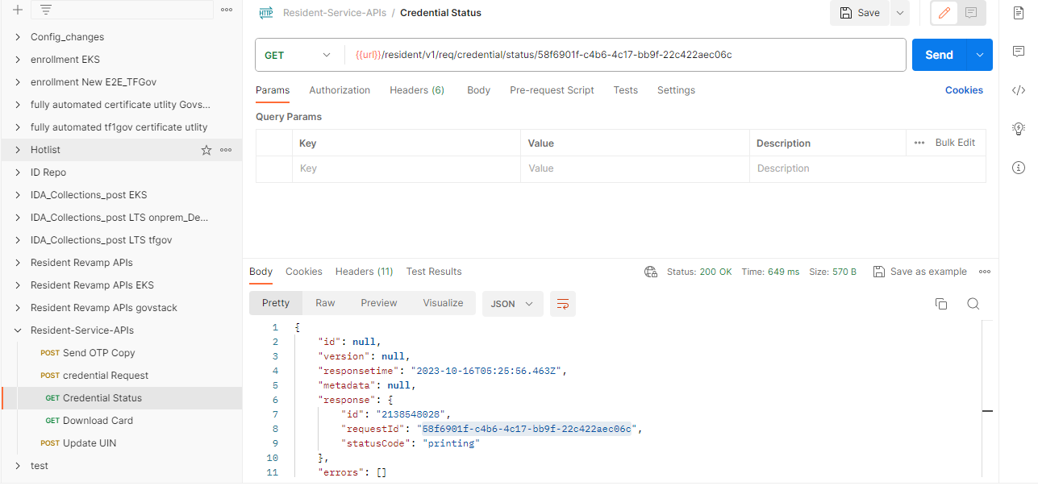The status of credential.

Notification

1. 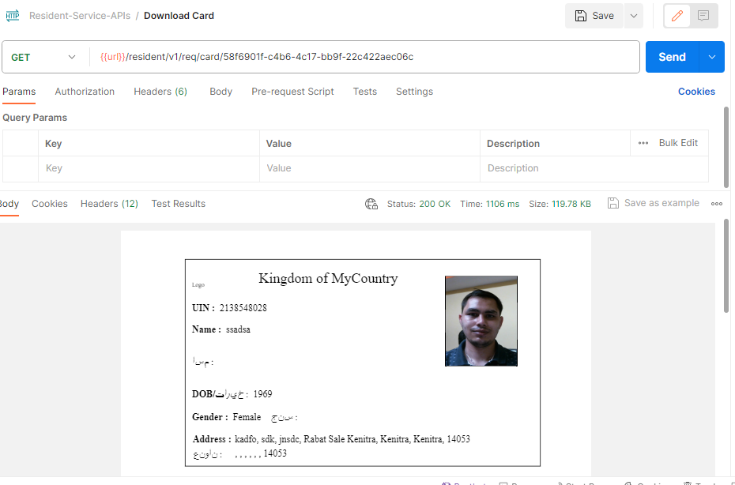Download card for credential retrieval.